**SINTERFACING 16X2 LCD DISPLAY WITH ATMEGA32 MICRO-CONTROLLER.S**

A 16x2 LCD display consists of 16 columns and 2 rows. Therefore this can easily display 32 alpha-numeric characters at a time. Each character is shown in pixels in 5x8 dot format (in 40 pixels shaped in a rectangle of 5 and 8 as its dimensions). The following is the pin description of the 16x2 LCD display.

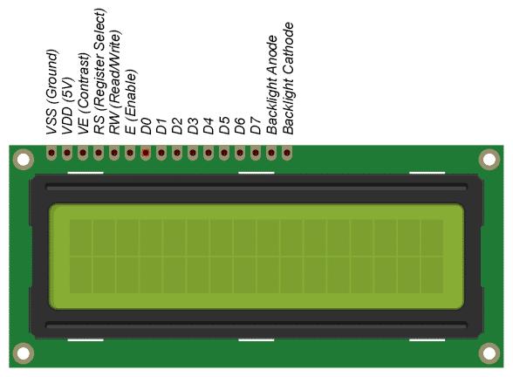

It has 16 different pins each with specific operation as listed below:

|  |  |  |  |
| --- | --- | --- | --- |
| Pin No: | Pin Name: | Pin description | Pin connection |
| 1 | VSS (Ground) | Ground pin for the module. | Connected to ground. |
| 2 | VDD (+5V) | Powers the module. | +5V voltage source. |
| 3 | VE (Contrast control +5V) | Controls the contrast of the characters displayed in this display. | Connected to a voltage source with a potentiometer in series. |
| 4 | RS (Register select) | Toggles between the data and command registers connected to micro-controller. | 0 - Command mode.  1 – Data mode. |
| 5 | R/W (Read/Write) | Toggles between writing and reading operation connected to micro-controller. | 0 – Write operation.  1 – Read operation. |
| 6 | E (Enable pin) | It is always high in order to perform read/write operation. | Connected to micro-controller and held as logic high (always). |
| 7-14 | D0-D7  (Data pins) | Pins for sending and receiving data and commands. | These pins are connected to the micro-controller for taking the values. |
| 15 | LED +  (Backlight anode) | Anode of backlight LED. | Connected to +5V. |
| 16 | LED -  (Backlight cathode) | Cathode of backlight LED. | Connected to ground. |

There are two modes for operating this LCD panel. They are:

1. **Command mode.**
2. **Data mode.**

The **command mode** is selected by making the pin 4 (RS pin) as logic low (0V). In this mode the micro-controller will give commands for the LCD module to operate in the desired way.

The **data mode** is selected by making the pin 4 (RS pin) as logic high (+5V). In this mode the micro-controller will give the data which we would like to display in the LCD module.

There are some inbuilt commands in this LCD module. They are:

|  |  |
| --- | --- |
| **Hex code** | **Respective command to LCD** |
| 01 | Clears the display. |
| 02 | Return home. (cursor will be placed at its default place) |
| 04 | Decrement the cursor (shifts the cursor to left) |
| 06 | Increment the cursor (shifts the cursor to right) |
| #def | Shift the display right. |
| 07 | Shift the display left. |
| 08 | Display OFF, cursor OFF. |
| 0A | Display OFF, cursor ON. |
| 0C | Display ON, cursor OFF. |
| 0E | Display ON, cursor blinking. |
| 0F | Display ON, cursor blinking. |
| 10 | Shift cursor position to left. |
| 14 | Shift cursor position to right. |
| 18 | Shift the entire display to left. |
| 1C | Shift the entire display to right. |
| 80 | Force cursor to beginning of 1st line. |
| C0 | Force cursor to beginning of 2nd line. |
| 38 | Activate 2 lines in 5x7 Matrix (8-bit mode). |
| 28 | Activate 2 lines in 5x7 Matrix (4-bit mode). |

This LCD module can work in two different modes. They are:

1. **8-bit mode.**
2. **4-bit mode.**

In the **8-bit mode** the data which is taken by the LCD module is of 8-bit length. The data which is sent directly from the micro-controller is accessed.

In the **4-bit mode** the data which sent by the micro-controller is split into two 4-bit data, and then accessed nibble-by-nibble. First the higher nibble is accessed and then the lower nibble.

Each mode has its own importance. In 4-bit mode the space of the circuit will be reduced, because we will be using only 4 channels for sending the data or commands, due to this the time taken to send one piece of data increases. But in the case of 8-bit mode, even though the space is increased by increasing the channels, the time for transmitting the data is very much less when compared to 4-bit mode. So the design considerations will affect the mode which we are going to use.

There are two operations of this LCD module. They are:

1. **Read.**
2. **Write.**

If the pin 5 (R/W pin) is logic high (+5V), then the read operation is executed and if the pin value is logic low (0V), then the write operation is executed. In the day-to-day applications the read operation is not seen. Mostly we will use this module to display the input which we give to it. So, the pin is always set logic low (0V).

**Problem statement:** Display the given input characters on LCD display in 8-bit mode.

Whenever we use a LCD display module, we have to write the functions for reading the input (either command or data), and for printing the taken inputs.

**Algorithm:**

1. Define the functions for taking commands, data, and for print operation.
2. Initialize the ports for input and output operations.
3. Give the respective commands for the required operations.
4. Give the inputs for displaying them in a while loop to show it continuously.

The following are the commands which we are going to use in our experiment:

|  |  |
| --- | --- |
| **Command** | **Description.** |
| 0X01 | Clear the display. |
| 0X38 | Activate the two rows in 8-bit mode. |
| 0X0F | Display ON, cursor is blinking. |
| 0X80 | Force the cursor to first position of 1st line |
| 0XC0 | Force the cursor to first position of 2nd line. |

**The following is the circuit connection for the respective project:**

